Partial / residual correlation: AUDUSD and USDJPY
Method 07 / daily log returns / leave-currency-out USD factor / Alpari D1 full available history

Study setup
Logical pair: AUDUSD , USDJPY
Broker symbols: AUDUSD_i , USDJPY_i
Snapshot: 2026-11-03_majors_alpari_D1
Timeframe: D1
Matched return window: 1999-01-05 to 2026-11-02 (UTC bar dates)
Matched return count n: 7148
Dropped unfinished last bar dated 2026-11-03 UTC after a tick-volume check against the prior complete day.
USD-strength sign rule: minus log return when USD is the quote (EURUSD, GBPUSD, AUDUSD, NZDUSD); plus log return when USD is the base (USDJPY, USDCHF, USDCAD). EURGBP is never a constituent.
Control z constituents (5): EURUSD, GBPUSD, NZDUSD, USDCHF, USDCAD
z_t = equal-weight mean of those USD-strength returns on the same day
Complete matched rows (Excel): AUDUSD-USDJPY_Partial_D1.xlsx
Complete matched rows (HTML table): AUDUSD-USDJPY_Partial_D1_data.html

Method carried forward
Partial / residual correlation regresses each matched daily log return of close, ln(close_t / close_t-1), on the same leave-currency-out USD strength factor z, then takes Pearson correlation of the two residual series. Quotes are not inverted. z is the equal-weight mean of USD-strength returns from other majors that do not share a non-USD currency with either leg; EURGBP is never a constituent. USD-strength is minus the log return when USD is the quote (EURUSD, GBPUSD, AUDUSD, NZDUSD) and plus the log return when USD is the base (USDJPY, USDCHF, USDCAD). OLS uses an intercept on each leg. rho_partial is symmetric under swap of the two symbols. It describes leftover linear co-movement after removing linear z; it is not a cause, not a lead, and not a trading signal. Daily rows are not independent and residuals are estimated, so the two-sided p-value and Fisher interval are secondary. Same-sample raw Pearson r is a side check only.

Regression on z
leg | intercept_a_or_c | slope_b_or_d | R2
AUDUSD | 1.279e-05 | -1.1922507 | 0.5830846
USDJPY | 5.822e-05 | 0.35256836 | 0.07539559

Results
rho_partial: 0.198113
Two-sided p-value: 3.50864e-64
Approximate 95% Fisher interval: [0.175738, 0.220285]
Same-sample raw Pearson r: -0.086668
rho_partial minus r: 0.284782

Conclusion
Over 7148 matched daily rows for AUDUSD and USDJPY after removing a leave-currency-out USD factor built from 5 constituents, rho_partial is 0.1981 (positive, weak residual linear link in this sample). Approximate 95% Fisher interval: [0.1757, 0.2203]. Same-sample raw Pearson r is -0.0867 (partial minus r = 0.2848). Leg R-squared on z: AUDUSD=0.5831, USDJPY=0.0754. Two-sided p under the usual independent-pairs model is 3.509e-64; residuals are estimated and daily FX rows are linked, so treat p as secondary. This does not establish cause, lead-lag, or a lasting trading rule.

Charts
Daily closes
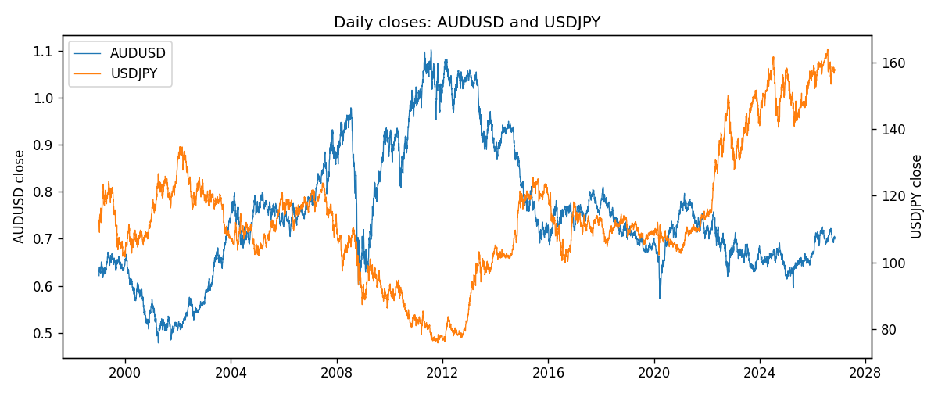
Log returns and control z
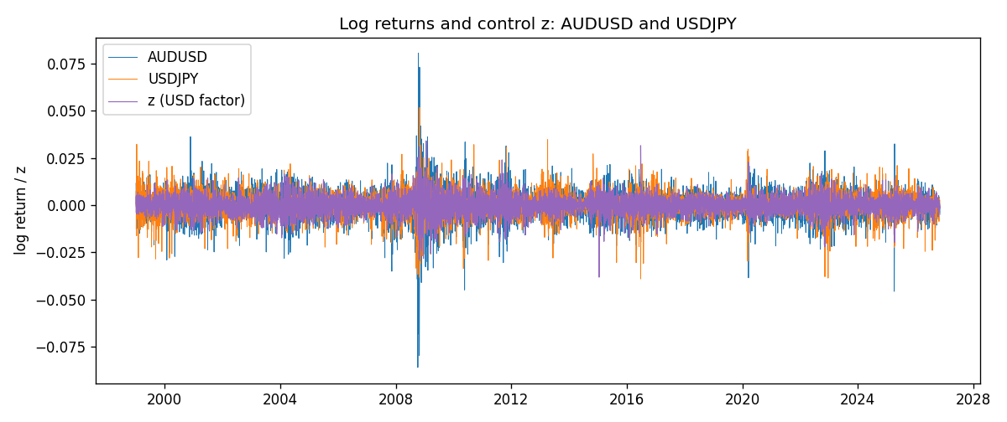
Residual scatter e_x vs e_y
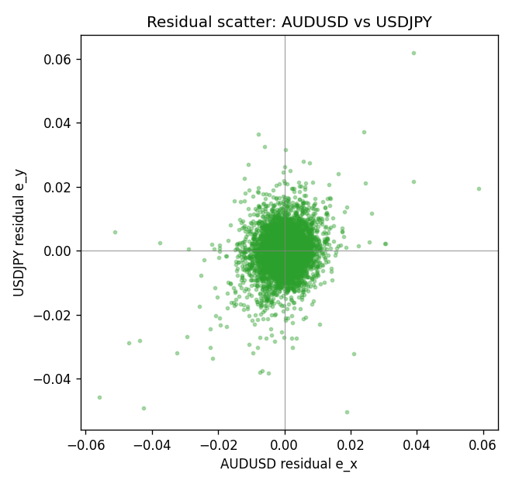

Data report
Every matched row that entered the partial correlation is stored in the sibling Excel workbook named AUDUSD-USDJPY_Partial_D1.xlsx. That file is the complete data archive for redrawing charts. Embedding all rows as a Word table is impractical at this length; the Word file holds the column list, column summaries, and the first and last 15 matched rows.
Columns: time, AUDUSD_open, USDJPY_open, AUDUSD_high, USDJPY_high, AUDUSD_low, USDJPY_low, AUDUSD_close, USDJPY_close, AUDUSD_tick_volume, USDJPY_tick_volume, AUDUSD_spread, USDJPY_spread, AUDUSD_real_volume, USDJPY_real_volume, AUDUSD_log_return, USDJPY_log_return, usd_strength_EURUSD, usd_strength_GBPUSD, usd_strength_NZDUSD, usd_strength_USDCHF, usd_strength_USDCAD, z, AUDUSD_fitted, USDJPY_fitted, AUDUSD_resid, USDJPY_resid
Column summaries (matched calculation rows)
column | count | mean | std | min | 25% | 50% | 75% | max
AUDUSD_open | 7148 | 0.75254463 | 0.13531821 | 0.4785 | 0.661255 | 0.7317 | 0.812135 | 1.10284
USDJPY_open | 7148 | 113.80278 | 19.266728 | 75.693 | 104.3275 | 110.969 | 120.725 | 163.824
AUDUSD_high | 7148 | 0.75660194 | 0.1358782 | 0.4878 | 0.6652025 | 0.7351 | 0.8182725 | 1.10795
USDJPY_high | 7148 | 114.30008 | 19.328348 | 76.001 | 104.8345 | 111.426 | 121.27175 | 163.978
AUDUSD_low | 7148 | 0.74848743 | 0.13462984 | 0.4775 | 0.65803 | 0.727775 | 0.80652 | 1.0975
USDJPY_low | 7148 | 113.28032 | 19.194266 | 75.402 | 103.8475 | 110.515 | 120.19 | 163.628
AUDUSD_close | 7148 | 0.75259994 | 0.13529833 | 0.4786 | 0.6614925 | 0.7318 | 0.81193 | 1.10169
USDJPY_close | 7148 | 113.81631 | 19.281858 | 75.811 | 104.3175 | 110.995 | 120.7025 | 163.851
AUDUSD_tick_volume | 7148 | 77889.255 | 138502.92 | 109 | 5574 | 43696 | 71619 | 1234623
USDJPY_tick_volume | 7148 | 106851.22 | 179762.89 | 197 | 10008.25 | 53482.5 | 93111.75 | 1803508
AUDUSD_spread | 7148 | 30.707051 | 16.89031 | 0 | 13 | 30 | 50 | 50
USDJPY_spread | 7148 | 20.16704 | 17.582453 | 0 | 6 | 11 | 30 | 50
AUDUSD_real_volume | 7148 | 5.2809589e+09 | 1.2584371e+11 | 0 | 0 | 0 | 0 | 3.811512e+12
USDJPY_real_volume | 7148 | 3.4953653e+10 | 1.6133327e+11 | 0 | 0 | 0 | 0 | 3.8834203e+12
AUDUSD_log_return | 7148 | 3.157e-05 | 0.00755018 | -0.08602525 | -0.00385014 | 0.00029168 | 0.00415111 | 0.0806166
USDJPY_log_return | 7148 | 5.267e-05 | 0.00620906 | -0.03908203 | -0.00319392 | 0.00012736 | 0.00340928 | 0.05184024
usd_strength_EURUSD | 7148 | 2.16e-06 | 0.0058013 | -0.03433183 | -0.00325609 | -0 | 0.00324218 | 0.03123819
usd_strength_GBPUSD | 7148 | 1.992e-05 | 0.00564699 | -0.03112653 | -0.00318167 | -3.426e-05 | 0.0031217 | 0.08388241
usd_strength_NZDUSD | 7148 | -1.914e-05 | 0.00764519 | -0.05966839 | -0.004586 | -0.00023666 | 0.00424201 | 0.07027433
usd_strength_USDCHF | 7148 | -6.945e-05 | 0.0065937 | -0.19545699 | -0.00334697 | 8.15e-05 | 0.00331954 | 0.09051364
usd_strength_USDCAD | 7148 | -1.226e-05 | 0.00514518 | -0.03859748 | -0.00283513 | 4.873e-05 | 0.00272781 | 0.03436319
z | 7148 | -1.575e-05 | 0.00483566 | -0.03818955 | -0.00276152 | -3.649e-05 | 0.00270844 | 0.03412846
AUDUSD_fitted | 7148 | 3.157e-05 | 0.00576531 | -0.04067689 | -0.00321635 | 5.63e-05 | 0.00330521 | 0.04554431
USDJPY_fitted | 7148 | 5.267e-05 | 0.0017049 | -0.01340621 | -0.0009154 | 4.535e-05 | 0.00101313 | 0.01209084
AUDUSD_resid | 7148 | -0 | 0.00487507 | -0.05577247 | -0.00238868 | 0.00011099 | 0.00261309 | 0.0587607
USDJPY_resid | 7148 | 0 | 0.0059704 | -0.0502875 | -0.00289956 | 0.00013494 | 0.00299056 | 0.06188353
First 15 matched rows (selected columns)
time | AUDUSD_close | USDJPY_close | AUDUSD_log_return | USDJPY_log_return | z | AUDUSD_fitted | USDJPY_fitted | AUDUSD_resid | USDJPY_resid
1999-01-05 | 0.6215 | 111.92 | -0.00080418179 | -0.00017868311 | 0.00068065232 | -0.00079871766 | 0.00029819673 | -5.4641266e-06 | -0.00047687984
1999-01-06 | 0.6289 | 112.77 | 0.011836351 | 0.0075660159 | 0.0046763805 | -0.0055626274 | 0.0017069641 | 0.017398978 | 0.0058590518
1999-01-07 | 0.6345 | 111.33 | 0.0088650256 | -0.012851583 | -0.0039347693 | 0.0047040221 | -0.0013290549 | 0.0041610035 | -0.011522528
1999-01-08 | 0.6347 | 110.8 | 0.00031515916 | -0.0047719894 | 0.0052685865 | -0.0062686854 | 0.0019157572 | 0.0065838446 | -0.0066877466
1999-01-11 | 0.6393 | 109.02 | 0.0072213815 | -0.016195423 | 0.00085610744 | -0.0010079042 | 0.00036005666 | 0.0082292856 | -0.016555479
1999-01-12 | 0.6362 | 112.6 | -0.0048608485 | 0.032310364 | -0.00093368241 | 0.0011259741 | -0.00027096662 | -0.0059868225 | 0.032581331
1999-01-13 | 0.6312 | 113.52 | -0.0078902098 | 0.0081373171 | -0.0047443683 | 0.005669267 | -0.0016144939 | -0.013559477 | 0.0097518111
1999-01-14 | 0.6295 | 113.52 | -0.002696916 | 0 | 0.00055200034 | -0.00064533225 | 0.00025283812 | -0.0020515838 | -0.00025283812
1999-01-15 | 0.634 | 114.15 | 0.007123101 | 0.0055343401 | 0.0049807441 | -0.0059255051 | 0.001814273 | 0.013048606 | 0.0037200671
1999-01-18 | 0.6346 | 114.16 | 0.00094592471 | 8.7600193e-05 | -0.0010358709 | 0.0012478083 | -0.00030699504 | -0.00030188362 | 0.00039459523
1999-01-19 | 0.6392 | 113.52 | 0.0072225153 | -0.0056219403 | -0.00017719068 | 0.00022404627 | -4.2515713e-06 | 0.006998469 | -0.0056176887
1999-01-20 | 0.64 | 112.91 | 0.0012507819 | -0.0053879917 | 0.0010562482 | -0.0012465221 | 0.00043061996 | 0.002497304 | -0.0058186116
1999-01-21 | 0.6405 | 113.87 | 0.00078094498 | 0.0084664056 | -0.0036683768 | 0.0043864154 | -0.0012351334 | -0.0036054704 | 0.009701539
1999-01-22 | 0.6327 | 114.56 | -0.012252745 | 0.0060412564 | 0.0026284509 | -0.003120982 | 0.00098492891 | -0.0091317632 | 0.0050563275
1999-01-25 | 0.6302 | 113.72 | -0.0039591468 | -0.0073594164 | 0.0017358934 | -0.0020568296 | 0.00067024136 | -0.0019023172 | -0.0080296578
Last 15 matched rows (selected columns)
time | AUDUSD_close | USDJPY_close | AUDUSD_log_return | USDJPY_log_return | z | AUDUSD_fitted | USDJPY_fitted | AUDUSD_resid | USDJPY_resid
2026-10-13 | 0.69821 | 158.305 | 0.0035007712 | -0.0018932826 | -0.0038502943 | 0.0046033067 | -0.0012992717 | -0.0011025355 | -0.00059401087
2026-10-14 | 0.69715 | 158.317 | -0.0015193215 | 7.5800166e-05 | 0.0033725299 | -0.0040081106 | 0.0012472676 | 0.0024887891 | -0.0011714674
2026-10-15 | 0.69191 | 158.024 | -0.0075447063 | -0.0018524319 | -0.006072424 | 0.0072526423 | -0.0020827243 | -0.014797349 | 0.0002302924
2026-10-16 | 0.69426 | 157.964 | 0.0033906408 | -0.00037976126 | -0.0036674168 | 0.0043852709 | -0.0012347949 | -0.0009946301 | 0.00085503363
2026-10-19 | 0.6978 | 158.517 | 0.0050859986 | 0.0034946841 | 0.00082988525 | -0.00097664073 | 0.00035081154 | 0.0060626394 | 0.0031438726
2026-10-20 | 0.70022 | 158.16 | 0.0034620426 | -0.0022546642 | -0.0036070338 | 0.0043132791 | -0.0012135057 | -0.00085123651 | -0.0010411585
2026-10-21 | 0.70275 | 158.108 | 0.0036066384 | -0.00032883504 | -0.0010533382 | 0.0012686337 | -0.00031315345 | 0.0023380047 | -1.5681587e-05
2026-10-22 | 0.70186 | 156.755 | -0.0012672558 | -0.0085942669 | -0.00055196849 | 0.00067087538 | -0.00013638637 | -0.0019381312 | -0.0084578805
2026-10-23 | 0.70353 | 156.81 | 0.0023765656 | 0.00035080446 | 0.0012082598 | -0.0014277581 | 0.00048421445 | 0.0038043237 | -0.00013340999
2026-10-26 | 0.70128 | 157.458 | -0.0032032829 | 0.0041238746 | 0.0019004035 | -0.0022529669 | 0.00072824242 | -0.00095031599 | 0.0033956322
2026-10-27 | 0.70245 | 157.894 | 0.0016669876 | 0.0027651658 | 0.0023858356 | -0.0028317237 | 0.00089939043 | 0.0044987113 | 0.0018657753
2026-10-28 | 0.70533 | 157.743 | 0.0040915541 | -0.00095679538 | 0.00021455589 | -0.00024301386 | 0.00013386588 | 0.004334568 | -0.0010906613
2026-10-29 | 0.70245 | 157.683 | -0.0040915541 | -0.00038043789 | -0.0022899234 | 0.0027429534 | -0.0007491343 | -0.0068345075 | 0.00036869641
2026-10-30 | 0.70316 | 157.516 | 0.0010102376 | -0.0010596481 | -0.0001417041 | 0.00018173736 | 8.2598766e-06 | 0.00082850027 | -0.001067908
2026-11-02 | 0.69971 | 157.933 | -0.0049184984 | 0.0026438521 | -0.0014304365 | 0.0017182295 | -0.0004461064 | -0.0066367279 | 0.0030899585

